RESOLUTION NO.__________

RE: CERTIFICATE OF APPROPRIATENESS UNDER THE
PROVISIONS OF THE ACT OF THE PENNSYLVANIA
LEGISLATURE 1961, JUNE 13, P.L. 282 (53
SECTION 8004) AND BETHLEHEM ORDINANCE NO.
3952 AS AMENDED.

WHEREAS, it is proposed to replace the existing back door and garage door at 127-129 East Third Street.

NOW, THEREFORE, BE IT RESOLVED by the Council of the City of Bethlehem that a Certificate of Appropriateness is hereby granted for the work.

Sponsored by: (s)

(s)

ADOPTED BY COUNCIL THIS DAY OF

(s)
President of Council

ATTEST:

(s)
City Clerk

HISTORIC CONSERVATION COMMISSION

CASE # 465 – It is proposed to replace the existing back door and garage door at 127-129 East Third Street.
OWNER/APPLICANT: East Allen Rentals LLC / Joseph Pearl

The Commission upon motion by Mr. Cornish seconded by Mr. Loush adopted the proposal that City Council issue a Certificate of Appropriateness for the proposed work described herein:
- The proposal to replace the existing back door and garage door at 127-129 East Third Street was presented by Joseph Pearl, B. Eaton, and Joe Piperato.
- The opening left by the removal of the existing deteriorated garage door will be filled with a white paneled garage door and an insulated, six-panel metal entrance door.
- The new garage door is 9' by 8' and the other door is 2'-6" by 6'-8".
- The siding around the new doors will be 1" x 6" dark grey lap fiber-cement lap siding.
- The existing aluminum siding above the doors will also be replaced with the same 1’x 6” fiber-cement siding in dark gray.
- Existing deteriorated wood windows on the second and third floors may be replaced with vinyl double-hung windows that fit the size of the existing masonry openings without blocking down. Vinyl was considered acceptable on the rear façade which is not highly visible from the rear street.
- Stucco may be installed in blind windows and will be recessed approximately 1”. The recommended stucco color is Red Clay. The stucco will have a smooth sand finish.
- The proposed motion was approved on a 7-0 vote. Mr. Roeder abstained due to a conflict of interest.

CU: cu

By: 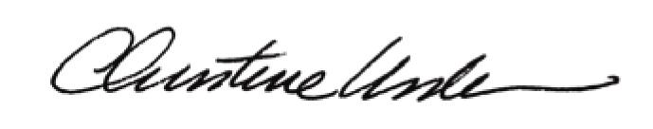

Date of Meeting: September 16, 2013 Title: Historic Officer

